Name-Aditi Sudhir Igade

Div-A Roll no-221081

PRN. No-22220311

Assignment-6

**PROBLEM STATEMENT: -**

Write a program to create an Arraylist and perform following operations on it: a) add , b) remove, c) display, d) Sort, e) Reverse

**OBJECTIVE: -**

To understand concepts of Arraylist by writing a program for creating Arraylist and performing operations.

## THEORY

Java **ArrayList** class uses a *dynamic*array for storing the elements. It is like an array, but there is *no size limit*. We can add or remove elements anytime. So, it is much more flexible than the traditional array. It is found in the *java.util* package. It is like the Vector in C++. The ArrayList in Java can have the duplicate elements also. It implements the List interface so we can use all the methods of the List interface here. The ArrayList maintains the insertion order internally. It inherits the AbstractList class and implements List interface.

**Algorithm-**

1. Create an ArrayList.
2. Add elements to Arraylist using Arraylist.add().
3. Sort the elements in Arraylist using Collections.sort()
4. Reverse the elements in Arraylist using Collections. reverse()
5. Create an iterator for Arraylist.
6. Display the elements of Arraylist using iterator.

**Code-**

import java.util.*;

public class Main

{

public static void main(String[] args) {

ArrayList<Integer> ar=new ArrayList<Integer>();

ar.add(1);

ar.add(2);

ar.add(3);

ar.add(4);

ar.add(5);

System.out.println("Displaying the elements of arraylist");

display(ar);

System.out.println("Reversing the arraylist elements");

reverse1(ar);

System.out.println("Sorted the elements");

sort1(ar);

System.out.println("Removing the elements from Arraylist");

remove1(ar);

}

public static void display(ArrayList<Integer> arr){

for(int i=0;i<arr.size();i++){

System.out.print(arr.get(i)+" ");

}

System.out.println();

}

public static void reverse1(ArrayList<Integer>arr1){

Collections.reverse(arr1);

display(arr1);

}

public static void sort1(ArrayList<Integer>arr2){

Collections.sort(arr2);

display(arr2);

}

public static void remove1(ArrayList<Integer> arr3){

arr3.remove(3);

arr3.remove(1);

display(arr3);

}

}

**Output-**

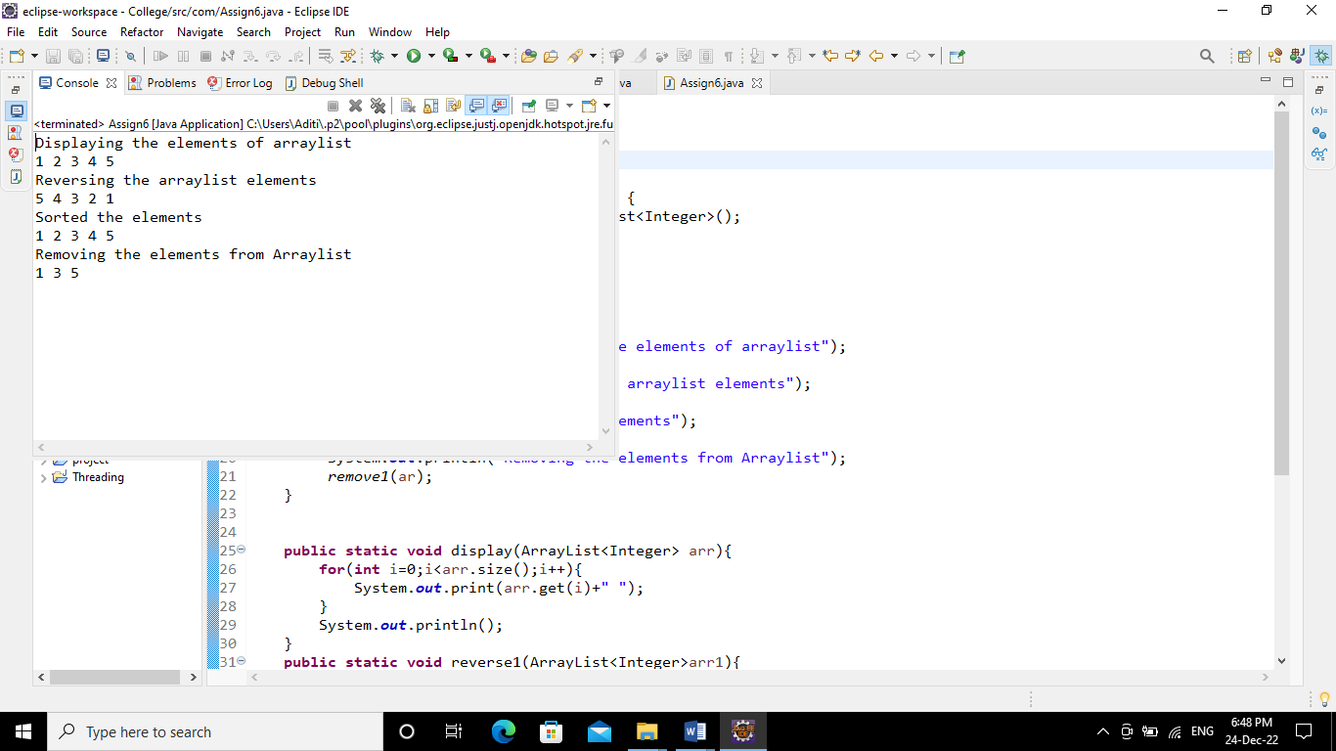

**Conclusion-** Able to understand and use the Arraylist in java.